**A COMPREHENSIVE ANALYSIS OF FINANCIAL PERFORMANCE: INSIGHTS FROM A LEADING BANKS**

**Project based on experimental learning program**

**INTRODUCTION**

Banking refers to a financial activity to manage and safeguard your hard-earned money. Banks cater to all sorts of individuals, small businesses, and large corporations. Banks offer financial management products, including various types of accounts and loans. They also provide easy access to funds via facilities like ATMs, debit cards, credit cards, etc. You can also utilise internet and mobile banking facilities offered by your bank .Financial management is integral in leading a quality life. A bank is a financial institution that enables you to manage your finances, thereby empowering you to live a financially secure life. Banks provide an array of financial services encompassing savings and investments, which help you gradually build a corpus. This article attempts to decode the age-old puzzle – what is banking and how it works. Read on to know more.Banking implies an activity where a licensed financial institution safeguards your money. You can park your hard-earned money in Current and [Savings Accounts](https://www.dbs.com/digibank/in/banking/account/savings-account). You can also earn attractive interest income by investing in interest generating term deposits. Banks also offer a wide variety of loans and overdraft facilities, depending on the type of account you open. Banks cater to a wide variety of customers – from retail investors to small and large business corporations. As a bank customer, you can visit your bank branch or enjoy remote banking services online through mobile or net banking

PROBLEM DEFINITION AND THINKING

Emathy Map

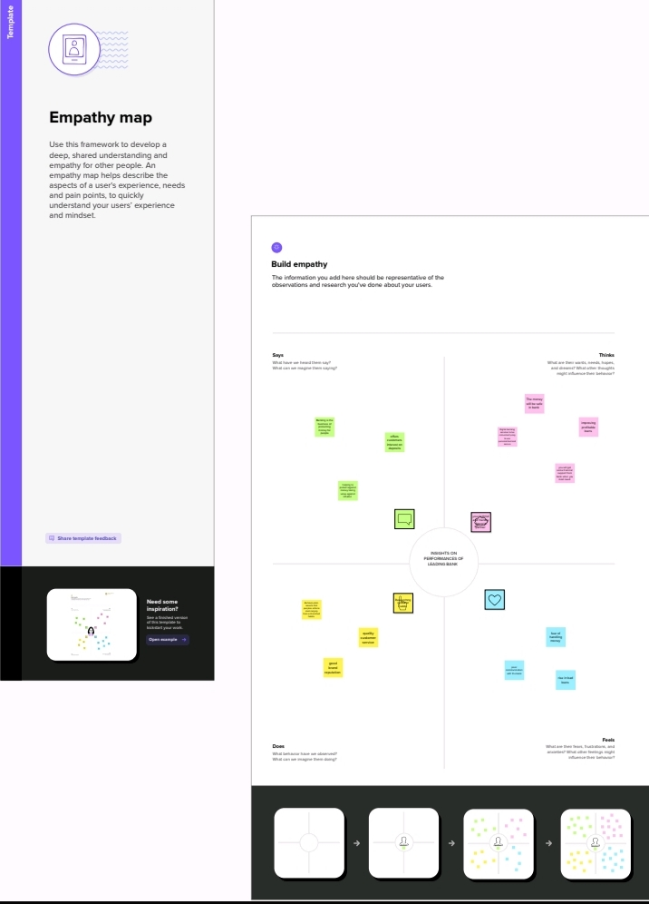

Brainstroming

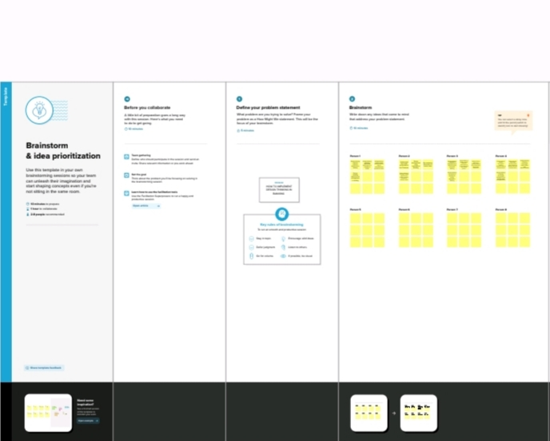

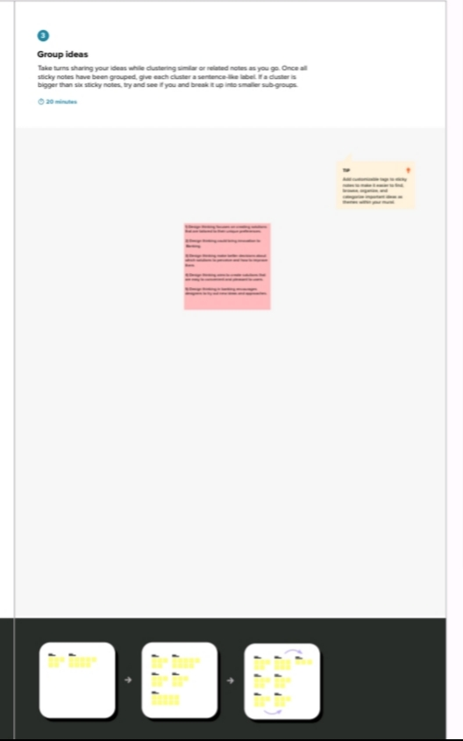

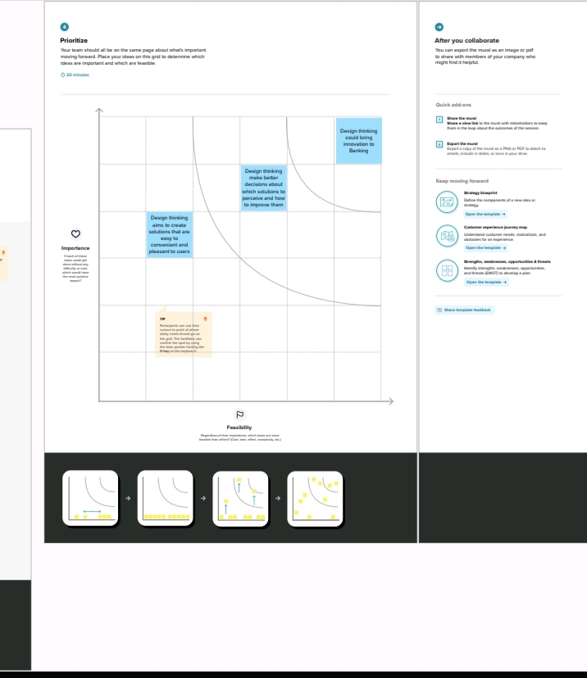

**RESULT**

**Dash board**

**A Dash board is a collection of several views,letting you compare a variety of data simultaneously .for example ,if you have a set of views that you review every day ,you can create a dashboard that displays all the views at once, rather than navigate to separate worksheet**

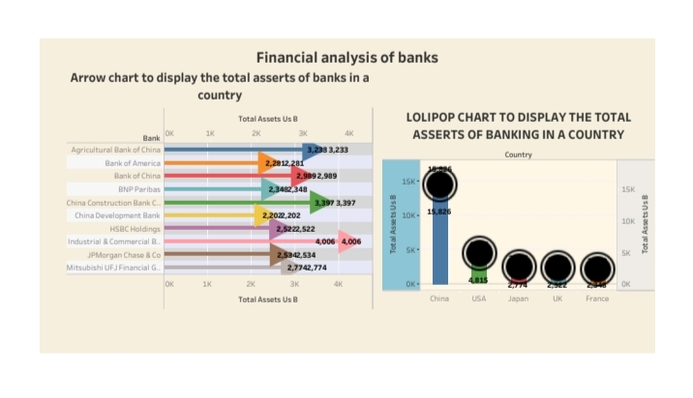

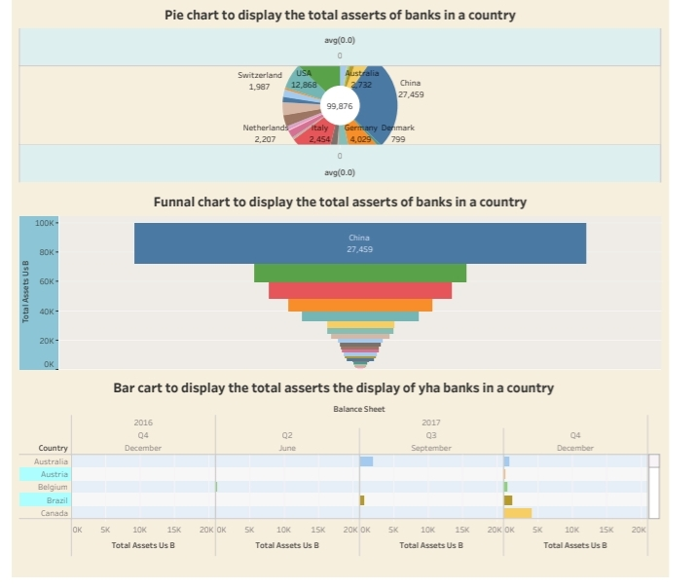

**Story**

**A Story is a sheet so the methods you use to create ,name and manage worksheet and databoards also apply to stories.at the same time a story is also a collection of sheets ,arranged in a sequence .each individual sheet in a story is called a story point**

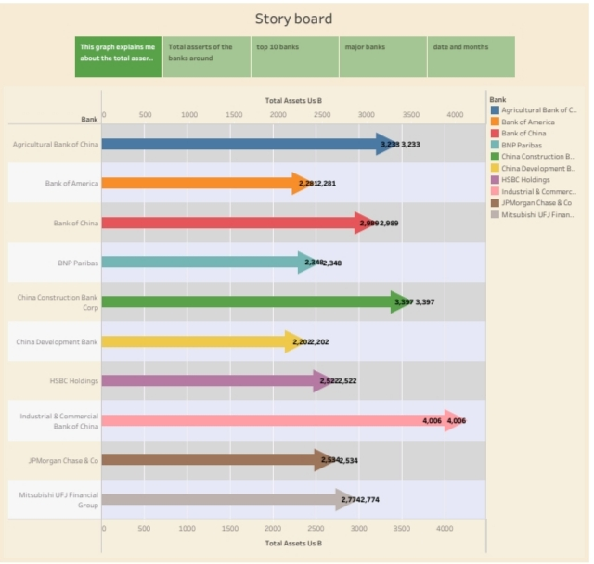

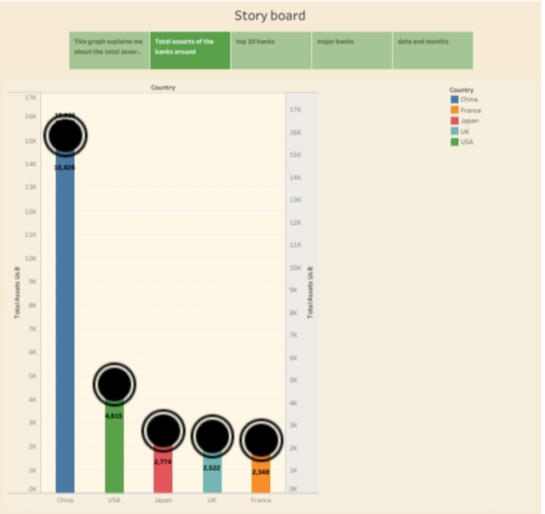

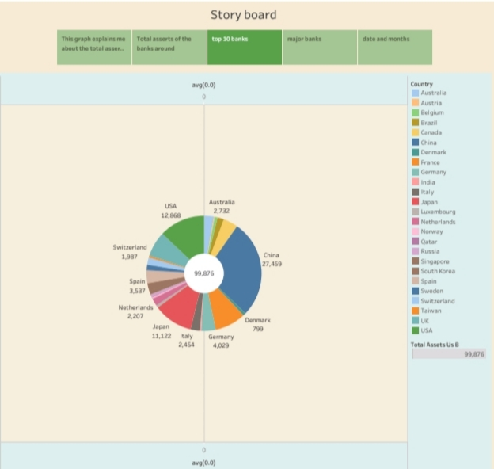

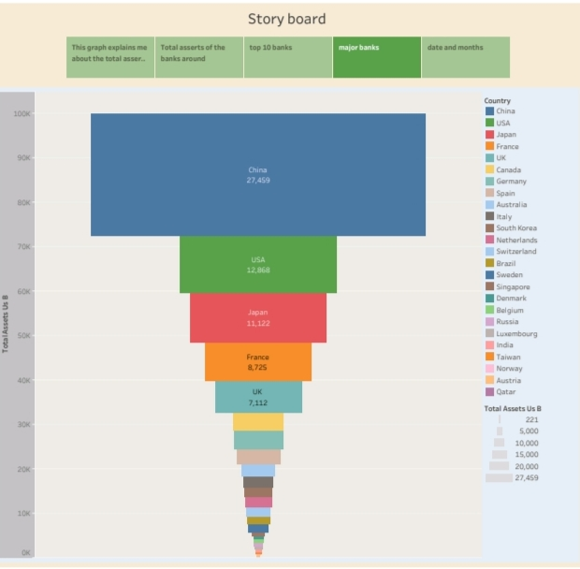

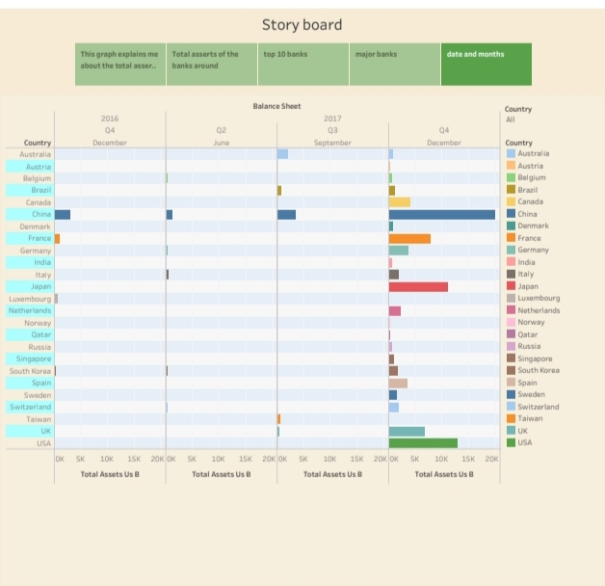

**ADVANTAGES OF BANKING**

* Bank accounts offer convenience. For example, if you have a checking account, you can easily pay by check or through online bill pay. ...
* Bank accounts are safe. ...
* It's an easy way to save money. ...
* Bank accounts are cheaper. ...
* Bank accounts can help you access credit.

DISAVANTAGES OF BANKING

1. The funds received from the commercial banks are of short duration and the procedure of obtaining funds is a time taking affair as there is a lot of verification that needs to be done from the bank end.
2. The bank can set difficult conditions for granting of loans.
3. Commercial bank accounts are more expensive than normal bank accounts.
4. Customer service is not up to mark at most of the commercial banks.

APPLICATION OF BANKING

The penetration of the Internet is very high in The Netherlands. You will find that most people will have a broadband Internet connection, have one or more mobile phones, and are using online banking applications and other Web sites. The Dutch society is very internationally focused, especially in the urban areas of the country.

Usability labs can be found in the major cities such as Amsterdam, Rotterdam, Utrecht, Eindhoven, and Groningen. However, most usability tests in The Netherlands will be conducted in an area called the “Randstad.” This is a conurbation in The Netherlands that consists of the four largest Dutch cities (Amsterdam, Rotterdam, The Hague, and Utrecht) and the surrounding areas. With approximately 8 million inhabitants, this area comprises almost half of the population of The Netherlands. Generally, there is not much difference between cities that are part of the Randstad.

An important point about researching in The Netherlands is that a qualitative approach to usability testing is generally employed. Participants find it fairly easy to talk about their experiences and are generally at ease using the thinking-aloud protocol. In most research situations, the test moderator and the participants interact in an informal manner. This often creates a relaxed atmosphere in which the participants feel at ease to be honest and critical.

Generally, participants arrive on time, but it is not unusual for them to arrive a few minutes late (depending on traffic conditions or parking opportunities nearby). Scheduling in additional time between sessions (e.g., 15 minutes) would allow for some flexibility. It is often useful to reconfirm appointments 1 or 2 days before testing to increase the chances of participants showing up on time (especially with young participants and students).

CONCLUSION

A banking system is a collection of institutions that provides us with financial services. These organizations are in charge of running a payment system, making loans, accepting deposits, and assisting with investments. The Reserve Bank of India (RBI), commercial banks, cooperative banks, and development banks comprise India’s banking system (development finance institutions). The core of India’s financial system is these institutions, which serve as a meeting point for savers and investors. Banks play a vital role in the development of poor countries by mobilizing resources and efficiently allocating them.

FUTURE SCOPE

The nature of the Indian economy over the last few years has been dicey.

Big brand names and the corporate sector have seen more downs than ups.

Due to changes in the economy, reputed firms are forced to shut down or sack thousands of employees.

There is no job security. This is a major reason why people in large numbers today choose to go for bank jobs instead.

The banking sector mainly recruits for three posts- Clerical cadre, Management and Trainee (MT), and [Probationary Officer (PO)](https://www.oliveboard.in/sbi-po/?ref=seoblog).

Other opportunities in this career path are Financial Service Representatives, Bank tellers, Bill and Account Collectors, Loan Officers, Financial Managers, Bookkeeping, and Audit Clerks.

Many people believe that bank jobs are only for students who have a Commerce or Economics background.

However, this is not true. Students with an Arts or Science background can also become bank officers.

The job of a banker demands great command over numbers and the right approach towards customer service.

You will be working on loans, credits, deposits and investment; you will be handling money matters, and deal with customers on a regular basis.